**Course: React + Django notes**

<https://gale.udemy.com/course/django-with-react-an-ecommerce-website/learn/lecture/24508410#overview>

git checkout -b <feature_branch_name>

git add .

git commit -m "<commit_message>"

git push -u origin <feature_branch_name>

git checkout main

git merge <feature_branch_name>

git push -u origin main

git push -u origin <feature_branch_name>

React redux frontend

Django backend

Aws postgresql database

Heroku hosting

Paypal integration for payments

bootstrap

Resources:

Postman, vscode, python

Vs code Extensions:

Es7 – code template shortcuts

Prettier – identations

Bracket pair colorizer (built-in) – add colors to open and close tags

Auto rename tag – html tag editor

6. Reach-Bootstrap Setup, Header & Footer Components

React Bootstrap and bootswatch(bootstrap themes)

Cdnjs – fonts – index.html add link- this add icons in front of text

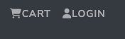

Imd shortcut – import destructing

import { second } from 'first'

used navbar component from react-bootstrap

main vh-80 for making footer down, basically expanding main in app.js – index.css

used container, Row, Col from reactbootstrap in Footer.js

filestructure so far

index.js

7. HomeScreen Product Listing

<https://github.com/vkfromkv/ecommerce_react_frontend.git> added local project to git.

Used card from bootstrap  
map() of js to map products

8. rating

Whats rem in css ?

npm install react-router-dom react-router-bootstrap

10. product screen details

App.js we catch the in url product/:**id =**

In product screen we get it in match.params.**id**

**Backend**

12. very imp video tells the basic working code needed for django

pip install virtualenv

in react….eccomerce/

virtualenv myenv

source myenv/bin/activate

pip install django

django-admin startproject backend

python manage.py startapp base

*startup basic concept is in Django we use multiple apps for user, products and etc  
but for covinace and our sake we only need **base**.

course uses function based views whereas professionally class base views are used

13. fetching data

Django-cors-header

Urls in backend/ - add api – basically all urls start with api/

Added products.py (dictionary of products) in backend

Urls.py in base - Urlpatterns (these are the ones we keep adding) linked with views.py

Views.py ->

We are using functional rest_framework

We use annotations api_views() and Response from Django rest_framework

DRF is a powerful toolkit for building **Web APIs** (like JSON-based REST APIs) with Django.

It gives you:

* Serialization (convert models ↔ JSON)
* Authentication
* Permissions
* Easy API views
* Browsable API UI (so helpful for devs!)
* Class-based views, routers, and more

**Frontend changes**  
Added proxy in frontend package.json – this tells where to forward to api calls.

UseEffect –

loads everytime component loads

useState = memory + reactivity

When the state changes, the component **re-renders** with the new value

15. database

Migrations in Django mean setting up database

In backend

Python3 manage.py migrate

Any changes in models.py will create a table (basically make changes in database)

Python2 manage.py createsuperuser

Varun

[varun@gmail.com](mailto:varun@gmail.com) – password: varun

15. Modeling the data

By default **user**  model is present in Django

from django.contrib.auth.models import User

We need to create others manually (writing code)

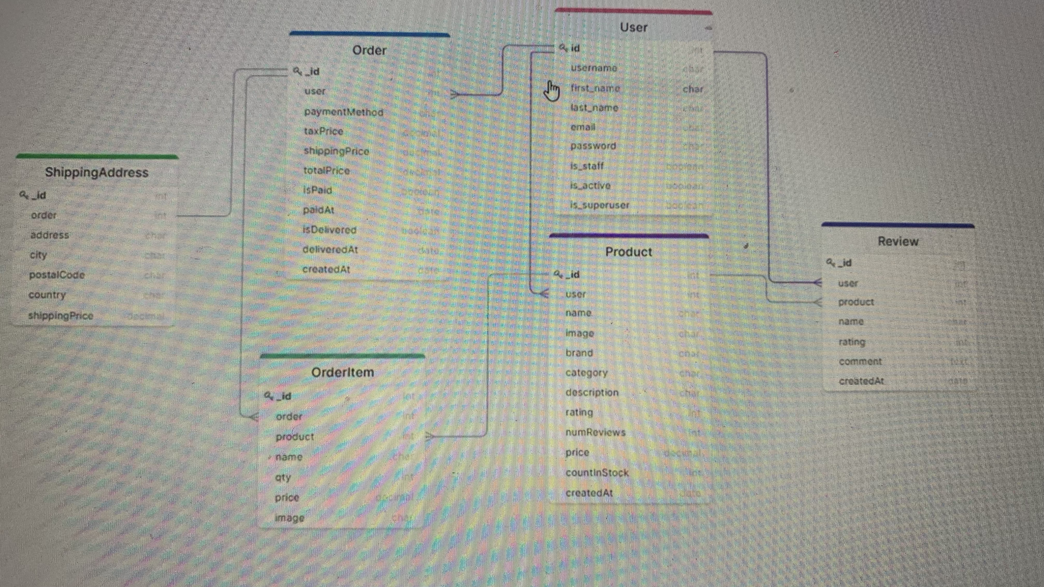

Class Product(**models.Model**) - **models.Model**  this turns class into model

user = models.ForeignKey(User, on_delete=models.SET_NULL)

"If the user is deleted, set this field to NULL" But also: "This field can never be NULL" - there is a conflict but still this is what we are using in the course

After creating product class(model)

In admin.py register your model-

admin.site.register(Product)

class ShippingAddress(models.Model):

order = models.OneToOneField(Order, on_delete=models.CASCADE, null=True, black=True) -> if order is deleted shippingAddress gets deleted

pip install pillow – this is an Image processing library

Serializing data

* **From model to JSON** (for sending to frontend or API clients)
* **From JSON to model** (for creating or updating data in the database)

Settings.py file for uploading images and it go directly to MEDIA_ROOT

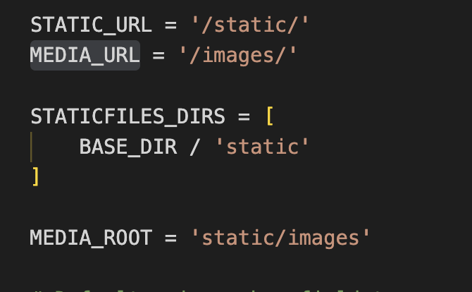

Redux patterns

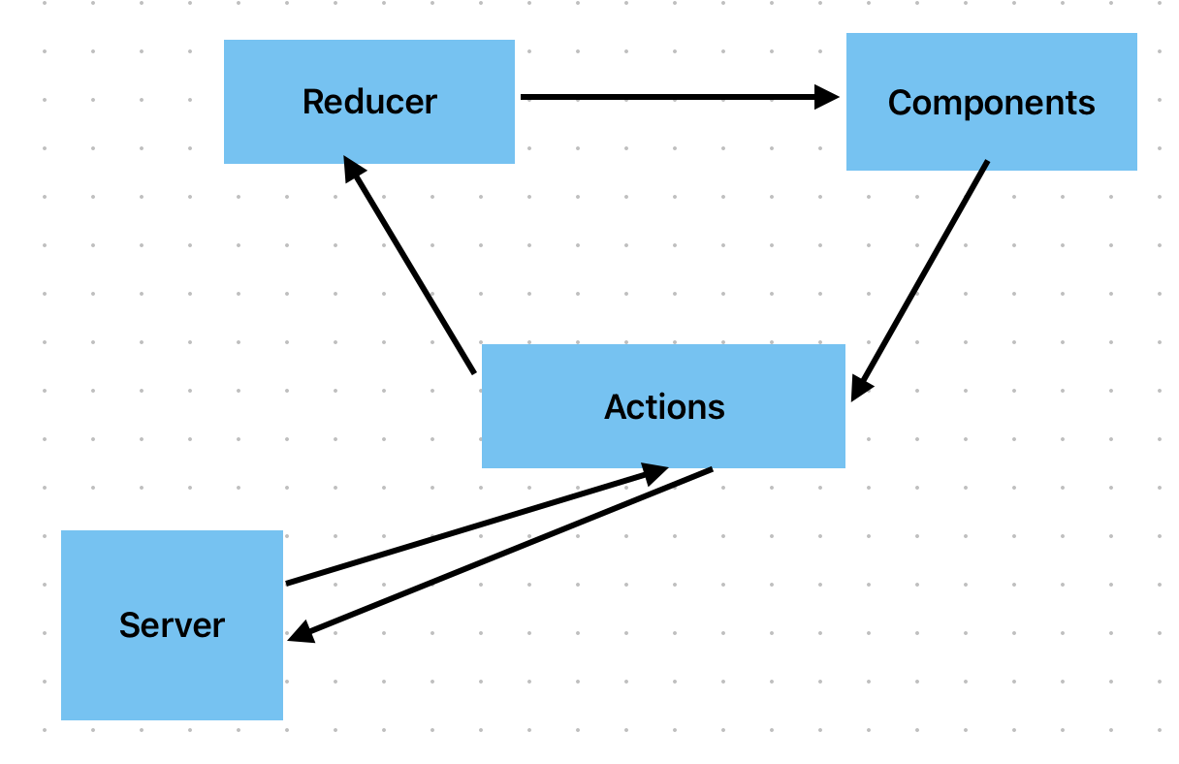

So, the way that **state is changed** is through REDUCERS OR REDUCER functions, and they're basically just **functions that accept actions** and they're responsible for manipulating and **passing the state down to components**.

***Redux is independent of react